Elijah Andrushenko

CPTS 453

Graph Theory

11-20-2019

Homework 6

1.

Let G be a K-regular graph and let D be a degree matrix so that

$$D_{ij}=\left\{\begin{aligned} deg⁡(v_{i}), &i=j \\ 0, &i≠j\end{aligned}\right.$$

Then let D be a scalar matrix with all diagonal entries, k. Then let suppose x is an Eigen vector which corresponds to the Eigen value d of A which is

$$Ax=dx$$

Then suppose we have the Laplacian matrix

$$L=D-A$$

Then we have

$$Lx=\left(D-A\right)x$$

$$Lx=Dx-Ax$$

$$Lx=kx-dx$$

$$Lx=\left(k-d\right)x$$

Note that

$Ax=dx$ And $Dx=kx$

Because we let D be a scalar matrix with all diagonals being equal to k.

Therefore x is an Eigen vector of L that corresponds to the Eigen value $k-d.$

Then we can see that

$$Dx=\left[\begin{matrix}k & 0 & . & . & 0 \\ 0 & k & . & . & . \\ . & . & & & . \\ . & . & & & . \\ 0 & . & . & . & k\end{matrix}\right]\left[\begin{matrix}x_{1} \\ x_{2} \\ . \\ . \\ x_{n}\end{matrix}\right]=\left[\begin{matrix}{kx}_{1} \\ {kx}_{2} \\ . \\ . \\ {kx}_{n}\end{matrix}\right]=k\left[\begin{matrix}x_{1} \\ x_{2} \\ . \\ . \\ x_{n}\end{matrix}\right]=kx$$

2.

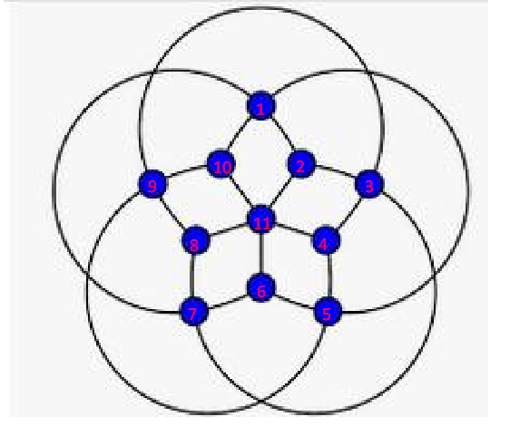

Laplacian Matrix: $L=D-A$

D is the Degree Matrix and A is the Adjacency Matrix

$$D=\left[\begin{matrix}4 & 0 & 0 & 0 & 0 & 0 & 0 & 0 & 0 & 0 & 0 \\ 0 & 3 & 0 & 0 & 0 & 0 & 0 & 0 & 0 & 0 & 0 \\ 0 & 0 & 4 & 0 & 0 & 0 & 0 & 0 & 0 & 0 & 0 \\ 0 & 0 & 0 & 3 & 0 & 0 & 0 & 0 & 0 & 0 & 0 \\ 0 & 0 & 0 & 0 & 4 & 0 & 0 & 0 & 0 & 0 & 0 \\ 0 & 0 & 0 & 0 & 0 & 3 & 0 & 0 & 0 & 0 & 0 \\ 0 & 0 & 0 & 0 & 0 & 0 & 4 & 0 & 0 & 0 & 0 \\ 0 & 0 & 0 & 0 & 0 & 0 & 0 & 3 & 0 & 0 & 0 \\ 0 & 0 & 0 & 0 & 0 & 0 & 0 & 0 & 4 & 0 & 0 \\ 0 & 0 & 0 & 0 & 0 & 0 & 0 & 0 & 0 & 3 & 0 \\ 0 & 0 & 0 & 0 & 0 & 0 & 0 & 0 & 0 & 0 & 5\end{matrix}\right]$$

$$A=\left[\begin{matrix}0 & 1 & 0 & 0 & 1 & 0 & 1 & 0 & 0 & 1 & 0 \\ 1 & 0 & 1 & 0 & 0 & 0 & 0 & 0 & 0 & 0 & 1 \\ 0 & 1 & 0 & 1 & 0 & 0 & 1 & 0 & 1 & 0 & 0 \\ 0 & 0 & 1 & 0 & 1 & 0 & 0 & 0 & 0 & 0 & 1 \\ 1 & 0 & 0 & 1 & 0 & 1 & 0 & 0 & 1 & 0 & 0 \\ 0 & 0 & 0 & 0 & 1 & 0 & 1 & 0 & 0 & 0 & 1 \\ 1 & 0 & 1 & 0 & 0 & 1 & 0 & 1 & 0 & 0 & 0 \\ 0 & 0 & 0 & 0 & 0 & 0 & 1 & 0 & 1 & 0 & 1 \\ 0 & 0 & 1 & 0 & 1 & 0 & 0 & 1 & 0 & 1 & 0 \\ 1 & 0 & 0 & 0 & 0 & 0 & 0 & 0 & 1 & 0 & 1 \\ 0 & 1 & 0 & 1 & 0 & 1 & 0 & 1 & 0 & 1 & 0\end{matrix}\right]$$

$$L=\left[\begin{matrix}4 & -1 & 0 & 0 & -1 & 0 & -1 & 0 & 0 & -1 & 0 \\ -1 & 3 & -1 & 0 & 0 & 0 & 0 & 0 & 0 & 0 & -1 \\ 0 & -1 & 4 & -1 & 0 & 0 & -1 & 0 & -1 & 0 & 0 \\ 0 & 0 & -1 & 3 & -1 & 0 & 0 & 0 & 0 & 0 & -1 \\ -1 & 0 & 0 & -1 & 4 & -1 & 0 & 0 & -1 & 0 & 0 \\ 0 & 0 & 0 & 0 & -1 & 3 & -1 & 0 & 0 & 0 & -1 \\ -1 & 0 & -1 & 0 & 0 & -1 & 4 & -1 & 0 & 0 & 0 \\ 0 & 0 & 0 & 0 & 0 & 0 & -1 & 3 & -1 & 0 & -1 \\ 0 & 0 & -1 & 0 & -1 & 0 & 0 & -1 & 4 & -1 & 0 \\ -1 & 0 & 0 & 0 & 0 & 0 & 0 & 0 & -1 & 3 & -1 \\ 0 & -1 & 0 & -1 & 0 & -1 & 0 & -1 & 0 & -1 & 5\end{matrix}\right]$$

3.

A)

<http://bluebit.gr/matrix-calculator/>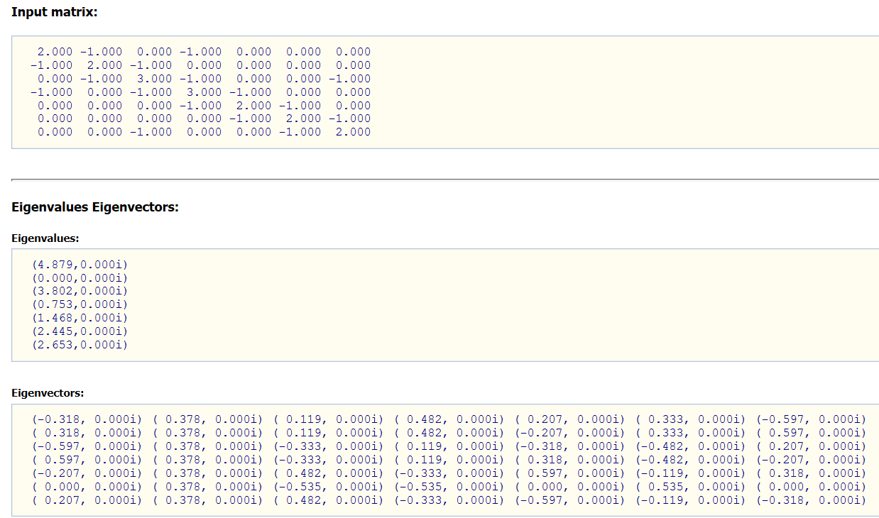

Equal

Graph A

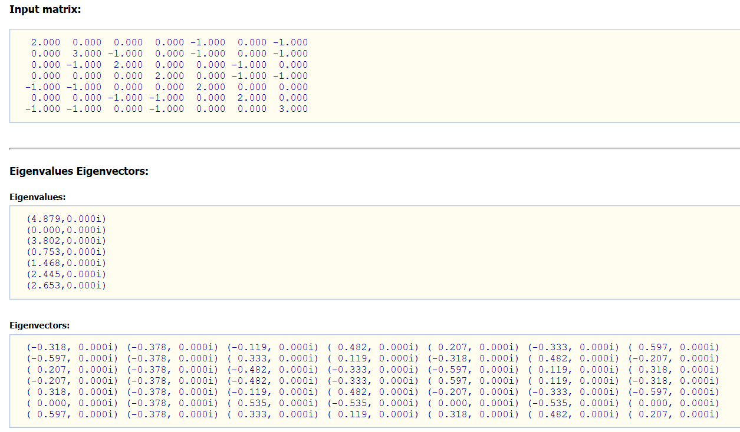

Graph B

B)

Graph B

Graph A

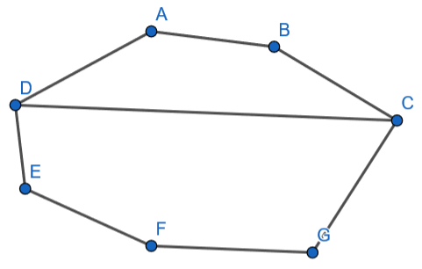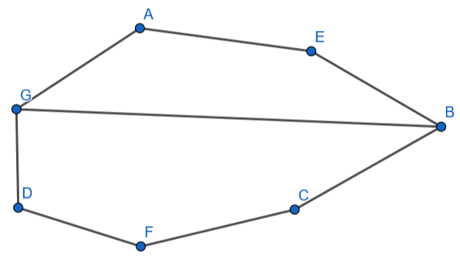

To check whether or not graph A and graph B are isomorphic we need to check the degree of every vertex on both graphs. Both graphs have 7 vertices.

**Degrees for Graph A**

$$\deg\left(A_{A}\right)=2 \deg\left(B_{A}\right)=3 \deg\left(C_{A}\right)=2 \deg\left(D_{A}\right)=2$$

$$\deg\left(E_{A}\right)=2 \deg\left(F_{A}\right)=2 \deg\left(G_{A}\right)=3$$

**Degrees for Graph B**

$$\deg\left(A_{B}\right)=2 \deg\left(B_{B}\right)=2 \deg\left(C_{B}\right)=3 \deg\left(D_{B}\right)=3$$

$$\deg\left(E_{B}\right)=2 \deg\left(F_{B}\right)=2 \deg\left(G_{B}\right)=2$$

**Match Vertices of Graph A and Graph B**

$A_{A}=A_{B},$ $E_{A}=B_{B}$, $B_{A}=C_{B}$, $C_{A}=G_{B},$ $F_{A}=F_{B},$ $D_{A}=E_{B},$ $G_{A}=D_{B}$

Incidence relation is preserved and therefore graph A and graph B are in fact isomorphic.

4.

Since it’s a path we know that the adjacency matrix number of ones in symmetric positions is 2n. Since this is true then it is known that the adjacency matrix of the path $P_{n}>2.$

First we have

$$A_{n}=\left[\begin{matrix}0 & 1 & 0 & … & … \\ 1 & 0 & 1 & … & … \\ 0 & 1 & 0 & 1 & … \\ … & … & … & … & … \\ … & … & … & … & …\end{matrix}\right]$$

$$A_{n}-{sI}_{n}=\left[\begin{matrix}-s & 1 & 0 & … & … \\ 1 & -s & 1 & … & … \\ 0 & 1 & -s & 1 & … \\ … & … & … & … & … \\ … & … & … & … & …\end{matrix}\right]$$

$$\det\left(A_{n}-{sI}_{n}\right)={\det\left[\begin{matrix}-s & 1 & 0 & … & … \\ 1 & -s & 1 & … & … \\ 0 & 1 & -s & 1 & … \\ … & … & … & … & … \\ … & … & … & … & …\end{matrix}\right]}_{n}= -s {\det\left[\begin{matrix}-s & 1 & 0 & … & … \\ 1 & -s & 1 & … & … \\ 0 & 1 & -s & 1 & … \\ … & … & … & … & … \\ … & … & … & … & …\end{matrix}\right]}_{n-1}+{\det\left[\begin{matrix}1 & 1 & … & … & … \\ 0 & -s & 1 & … & … \\ 0 & 1 & -s & 1 & … \\ … & … & … & … & … \\ … & … & … & … & …\end{matrix}\right]}_{n-1}= -s {\det\left[\begin{matrix}-s & 1 & 0 & … & … \\ 1 & -s & 1 & … & … \\ 0 & 1 & -s & 1 & … \\ … & … & … & … & … \\ … & … & … & … & …\end{matrix}\right]}_{n-1}-{\det\left[\begin{matrix}1 & 1 & … & … & … \\ 0 & -s & 1 & … & … \\ 0 & 1 & -s & 1 & … \\ … & … & … & … & … \\ … & … & … & … & …\end{matrix}\right]}_{n-1}= -s\det\left(A_{n-1}-{sI}_{n-1}\right)-\det\left(A_{n-2}-{sI}_{n-2}\right)$$

This shows that $n ≥3 , f_{n}\left(s\right)=-s f_{n-1}\left(s\right)-f_{n-2}\left(s\right).$